**SYNOPSIS**

**Report on**

**FACE DETECTION SYSTEM**

**By**

**PAWAN KUMAR SHARMA “2200290140107”**

**Session:2023-2024 (III Semester)**

Under the supervision of

**Prof. (Dr.) / Dr. / Mr AMIT GOYAL**

### KIET Group of Institutions, Delhi-NCR, Ghaziabad



### Department Of Computer Applications

**KIET GROUP OF INSTITUTIONS, DELHI-NCR, GHAZIABAD-201206**

(2023 - 2024)

**ABSTRACT:**

Face detection has undergone a transformative evolution through the integration of Artificial Neural Networks (ANN), Artificial Intelligence (AI), and Machine Learning (ML). ANN, particularly Convolutional Neural Networks (CNNs), serve as the foundation for modern face detection. They excel in feature extraction and pattern recognition. AI and ML techniques enhance adaptability and learning capabilities.

This synergy starts with data acquisition and preprocessing, often utilizing large labeled datasets. AI-driven data augmentation and preprocessing techniques contribute to model generalization. AI-powered real-time decision-making enables adaptability to varying conditions, improving detection accuracy. Machine learning, especially transfer learning, fine-tunes pre-trained models for efficient deployment, crucial for resource-constrained environments.

AI and ML also address ethical concerns by facilitating privacy-preserving algorithms and anonymization techniques, mitigating risks associated with surveillance. Applications now span security, healthcare, and human-computer interaction, including facial recognition and emotion detection.

Continued research in AI and ML promises increased accuracy and robustness in face detection. Ethical considerations remain vital to ensure responsible deployment. In 200 words, the integration of ANN, AI, and ML has revolutionized face detection, enabling a wide range of applications while emphasizing ethical and privacy concerns.

**TABLE OF CONTENTS**

1. Introduction 2
2. Project / Research Objective 4
3. Technology used 6
4. Research Methodology 7
5. Project / Research Outcome 10
6. Proposed Time Duration 11
7. References 12

**INTRODUCTION**

In this work, a software for human face detection and recognition is prepared. Initial implementation of this work is service oriented. However, the analysis and design are done to promote the work as product based. The work is entitled as Face Detection and Recognition System.

Face Detection is a application software to deal with human face. It has the provisions to collect image from the user so that they can detect the eyes, nose, mouth and whole face of human in the image.

There are various advantages of developing an software using face detection and recognition in the field of authentication. Face detection is easy and simple for humans, but not for computers. It has been regarded as the most complex and challenging problem in the field of computer vision due to large intra-class variations caused by the changes in facial appearance, lighting and expression. Face detection is the process of identifying one or more human faces in images or videos. It plays an important part in many biometric, security and surveillance systems, as well as image and video indexing systems. Face detection can be regarded as a specific case of object-class detection. In object-class detection, the task is to find the locations and sizes of all objects in an image that belong to a given class.

The project titled ‘Face Detection and Recognition System’, is to manage all the front end back end system of finding or detecting particular region in human face. This software helps the people looking for more advanced way of image processing system.Using this software they can easily find or detect faces in image and also recognize the face after saving that. Face-detection algorithms focus on the detection of frontal human faces. It is analogous to image detection in which the image of a person is matched bit by bit. The image matches with the image stores in database. Any facial feature changes in the database will invalidate the matching process.

A reliable face-detection approach based on the genetic algorithm and the eigen-face technique.

Firstly, the possible human eye regions are detected by testing all the valley regions in the gray-level image.Then the genetic algorithm is used to generate all the possible face regions which include the eyebrows, the iris, the nostril and the mouth corners.

Each possible face candidate is normalized to reduce both the lightning effect, which is caused by uneven illumination; and the shirring effect, which is due to head movement.The fitness value of each candidate is measured based on its projection on the eigenfaces. After a number of iterations, all the face candidates with a high fitness value are selected for further verification. At this stage, the face symmetry is measured and the existence of the different facial features is verified for each face candidate.

Face detection is gaining the interest of marketers. A webcam can be integrated into a television and detect any face that walks by. The system then calculates the race, gender, and age range of the face.

OBJECTIVE:

Whenever we implement a new system it is developed to remove the shortcomings of the existing system. The computerized mechanism has more edge than the manual system. The existing system is based on manual system which takes a lot of time to get the performance of the work. The proposed system is a web application and maintains a centralized repository of all related information. The system allows one to easily access the software and detect what he wants.

Viola-Jones algorithm:

There are different types of algorithms used in face detection. Here, we have used the Viola-Jones algorithm for face detection using the MATLAB program.

This algorithm works in the following steps:

1. Creates a detector object using Viola-Jones algorithm

2. Takes the image from the video

3. Detects features

4. Annotates the detected feature 8

SPECIFICATION OF MODULE:

Before starting to design a software product, it is extremely important to understand the precise requirements of the user and to document them properly.

The goal of the requirement analysis and specification phase is to clearly understand the customer’s requirements and to systematically organize these requirements in a specification document.

Login system requires simple hardware and software to be implemented. This is a highly cost-effective system that places no hard and fast restrictions on how environment and tools are to be used for its implementation. This is a highly flexible application from the view point of its execution in diverse environments. The technologies used for its development are all inbuilt since open-source software is used. So no copyright issues are involved for installing and executing this software.

GOALS OF PROPOSED SYSTEM:

a. Planned approach towards working: - The working in the organization will be well planned and organized. The data i.e. Image will be stored properly in database stores which will help in retrieval of information as well as its storage.

b. Accuracy: - The level of accuracy in the proposed system will be higher. All operation would be done correctly and it ensures that whatever information is coming from the center is accurate.

c. Reliability: - The reliability of the proposed system will be high due to the above stated reasons. The reason for the increased reliability of the system is that now there would be proper storage of information.

d. No Redundancy: - In the proposed system utmost care would be that no information is repeated anywhere, in storage or otherwise. This would assure economic use of storage space and consistency in the data stored.

e. Immediate retrieval of information: - The main objective of proposed system is to provide for a quick and efficient detection of required information. Any type of detection would be available whenever the user requires. f. Immediate storage of information: - In manual system there are many problems to store the largest amount of information for processing. g. Easy to Operate: - The system should be easy to operate and should be such that it can be developed within a short period of time and fit in the limited budget of the user.

FACE DETECTION:

The problem of face recognition is all about face detection. This is a fact that seems quite bizarre to new researchers in this area. However, before face recognition is possible, one must be able to reliably find a face and its landmarks. This is essentially a segmentation problem and in practical systems, most of the effort goes into solving this task. In fact the actual recognition based on features extracted from these facial landmarks is only a minor last step.

There are two types of face-detection problems:

1) Face detection in images and

2) Real-time face detection 10.

FACE DETECTION STEPS:

1. Pre-Processing: To reduce the variability in the faces, the images are processed before they are fed into the network. All positive examples that is the face images are obtained by cropping images with frontal faces to include only the front view. All the cropped images are then corrected for lighting through standard algorithms. 9

2. Classification: Neural networks are implemented to classify the images as faces or non faces by training on these examples. We use both our implementation of the neural network and the MATLAB neural network toolbox for this task. Different network configurations are experimented with to optimize the results.

3.Localization: The trained neural network is then used to search for faces in an image and if present localize them in a bounding box. Various Feature of Face on which the work has done on:- Position Scale Orientation Illumination.

FACE RECOGNIZATION:

There are two predominant approaches to the face recognition problem: Geometric (feature based) and photometric (view-based). As researcher interest in face recognition continued, many different algorithms were developed, three of which have been well studied in face recognition literature. Recognition algorithms can be divided into two main approaches:

1. Geometric: It is based on geometrical relationship between facial landmarks, or in other words the spatial configuration of facial features. That means that the main geometrical features of the face such as the eyes, nose and mouth are first located and then faces are classified on the basis of various geometrical distances.

2. Photometric: It is used to recover the shape of an object from a number of images taken under different lighting conditions. The shape of the recovered object is defined by a gradient map, which is made up of an array of surface.

PROJECT OBJECTIVES:

To develop an efficient Face Detection system with front end web interface and back-end database

FUNDAMENTAL STEPS IN IMAGE PROCESSING:

Fundamental steps in image processing are 1. Image acquisition: to acquire a digital image 2. Image pre-processing: to improve the image in ways that increases the chances for success of the other processes. 3. Image segmentation: to partitions an input image into its constituent parts of objects. 4. . Image description: to extract the features that result in some quantitative information of interest of features that are basic for differentiating one class of objects from another. 5. Image recognition: to assign a label to an object based on the information provided by its description. 6. Image segmentation: to convert the input data to a from suitable for computer processing

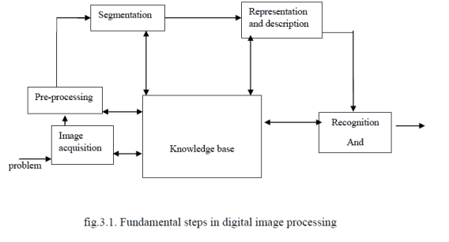

A simple image formation model:

Images are denoted by two-dimensional function f(x, y).f(x, y) may be characterized by 2 components:

1. The amount of source illumination i(x, y) incident on the scene

2. The amount of illumination reflected r(x, y) by the objects of the scene

3. f(x, y) = i(x, y)r(x, y), where 0 < i(x,y) < and 0 < r(x, y) < 1

image Formats (supported by MATLAB Image Processing Toolbox

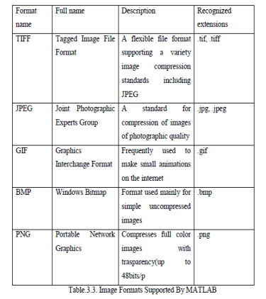

Gantt Chart

|  |  |  |  |  |  |  |  |  |  |
| --- | --- | --- | --- | --- | --- | --- | --- | --- | --- |
| **Date** | **Task Name** | **Week 1** | **Week 2** | **Week 3** | **Week 4** | **Week 5** | **Week 6** | **Week 7** | **Week 8** |
| **11/9/2023** | **Planning** |  |  |  |  |  |  |  |  |
| **18/09/2023** | **Requirement Analysis** |  |  |  |  |  |  |  |  |
| **29/09/2023** | **Design** |  |  |  |  |  |  |  |  |
| **11/10/2023** | **Coding** |  |  |  |  |  |  |  |  |
| **16/11/2023** | **Reporting** |  |  |  |  |  |  |  |  |